**EXP NO 7: DEMONSTRATE VIRTUALIZATION BY INSTALLING TYPE-2 HYPERVISOR IN YOUR DEVICE, CREATE AND CONFIGURE VM IMAGE WITH A HOST OPERATING SYSTEM (EITHER WINDOWS/LINUX).**

**DATE: 3-10-2025**

**AIM:**

To demonstrate virtualization by installing type-2 hypervisor in your device, create and configure VM image with a host operating system (either windows/linux).

**PROCEDURE:**

**STEP 1:** Download VMware workstation and installed as type 2 hypervisor.

**STEP2:** Download ubuntu or tiny OS as iso image file.

**STEP 3:** In VMware workstation->create new VM.

**STEP 4:** Do the basic configuration settings.

**STEP 5:** Created tiny OS virtual machine.

**STEP 6:** Launch the VM.

IMPLEMENTATION:

**STEP 1: DOWLOAD VMWARE WORKSTATION AND INSTALLED AS TYPE 2 HYPERVISOR**

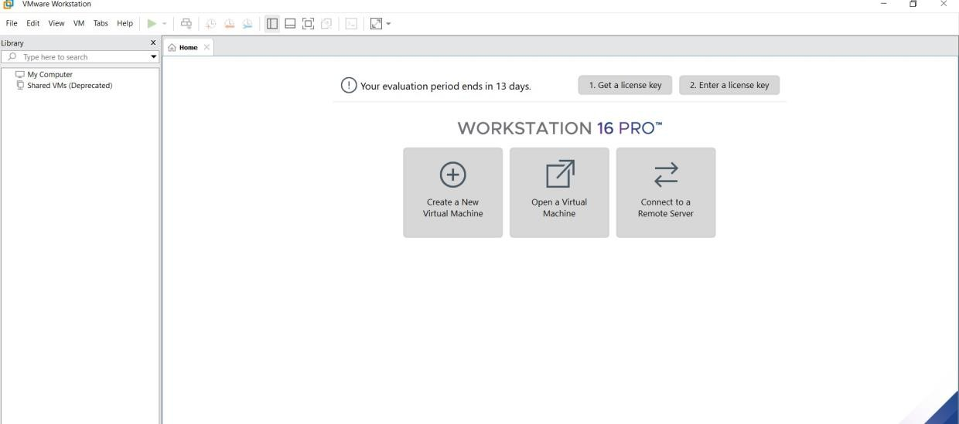

**STEP2: DOWLOAD UBUNTU OR TINY OS AS ISO IMAGE FILE**

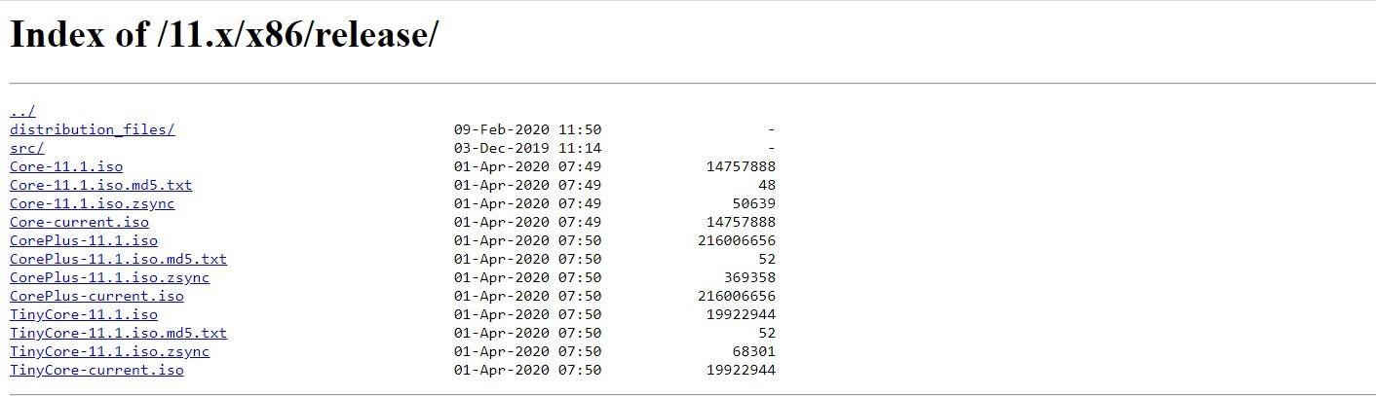

**STEP 3: IN VMWARE WORKSTATION->CREATE NEW VM**



**STEP 4: DO THE BASIC CONFIGURATION SETTINGS.**

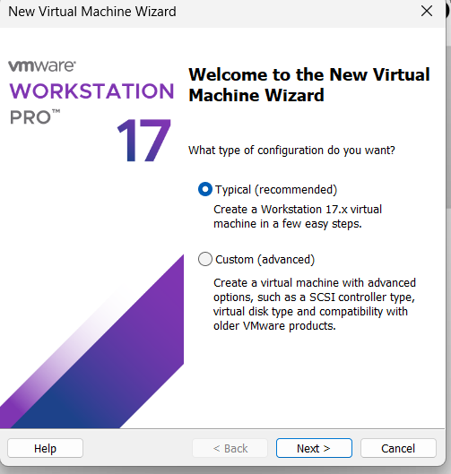

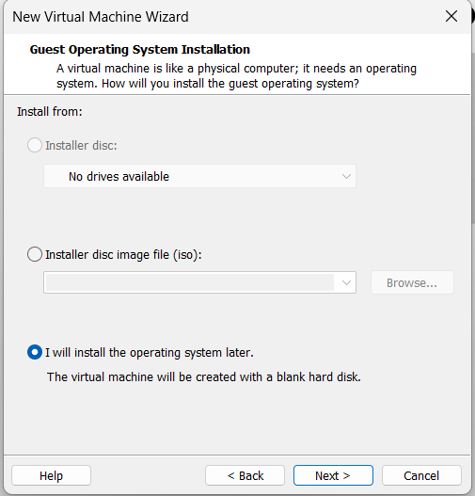

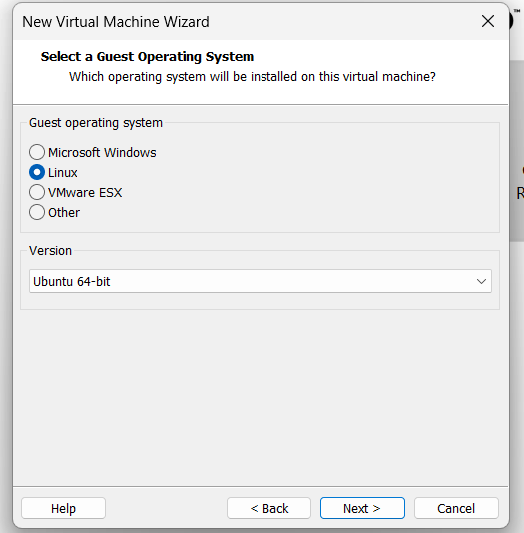

**STEP 5: CREATED TINYOS VIRTUAL MACHINE AND LAUNCH THE VM**

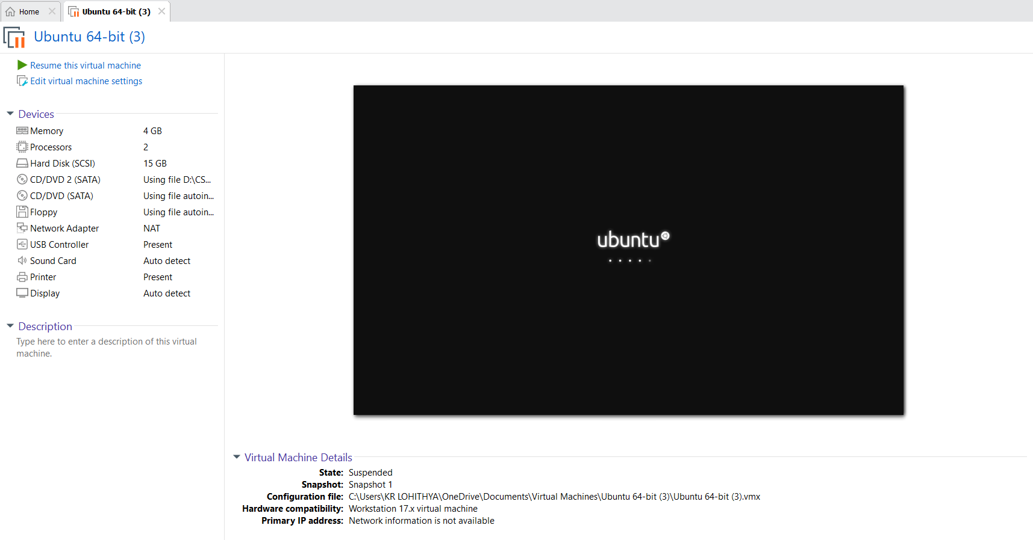

**RESULT:**

A Type-2 hypervisor (VirtualBox/VMware) was successfully installed on the host system. A virtual machine with the Linux/Windows operating system was created, configured, and executed successfully.